Window Shopper - Search Georgia Virtual Catalogs

Window Shopper is a new way to search Statewide Contracts for State entities that do not have access to Team Georgia Marketplace applications.

Step # | Do This:
1 | Sign in to Team Georgia Marketplace Window Shopper. If you have not created a User ID and Password, refer to the Window Shopper – Registration Quick Reference Guide or video.  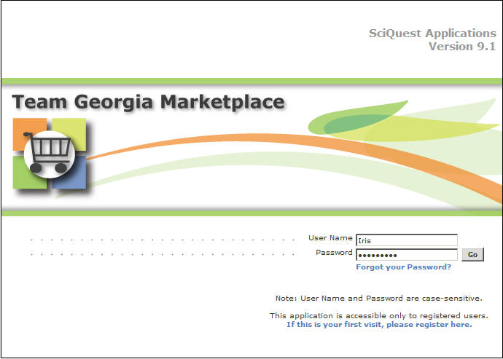
2 | The easiest way to “shop for everything” on the home/shop tab is to do a Keyword Search.  The example shows a keyword search for “PENS". To do a keyword search, enter the desired keyword into the Search field and click the Go button.  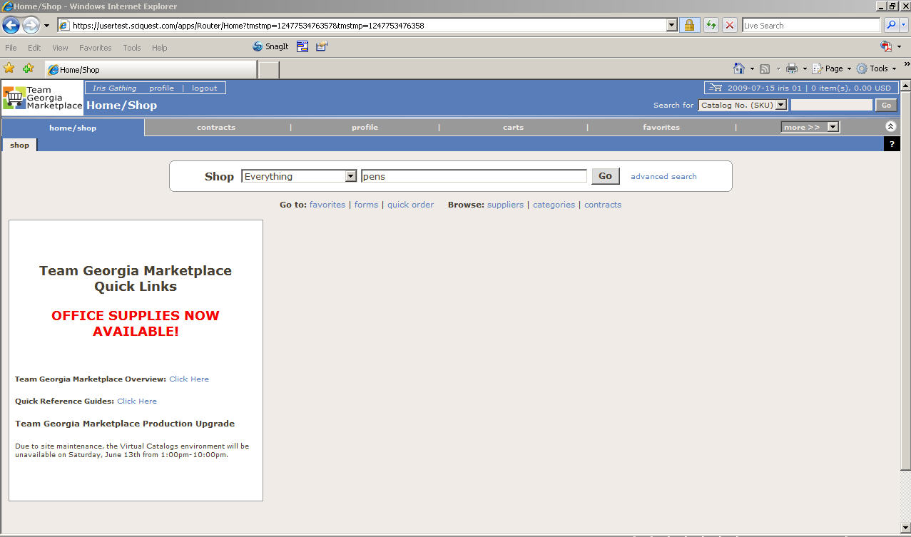
3 | The search results for pens show over 1400 results. There are several options you can use to narrow the search including:  - Add Keywords  - By Supplier  - By Category  - By Packaging UOM  The example shows “blue ink” added as an additional keyword.  To use the Add Keyword feature, enter the desired information into the Add Keyword field in the Refine and Filter Search box, and click the Go button.  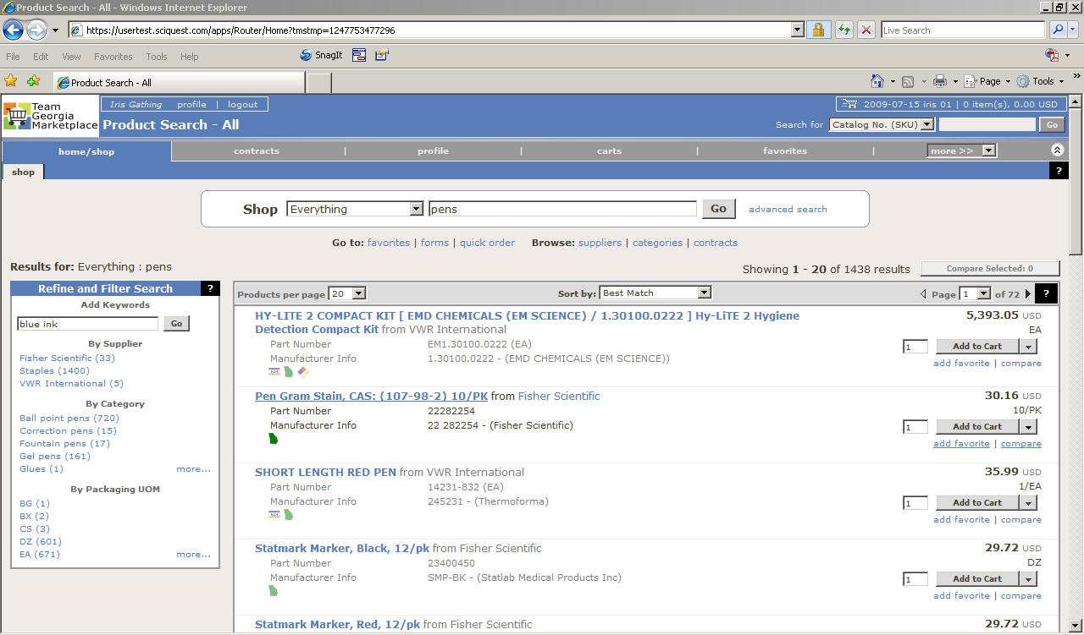
4 | Using the Add Keyword option narrowed the search to five results.  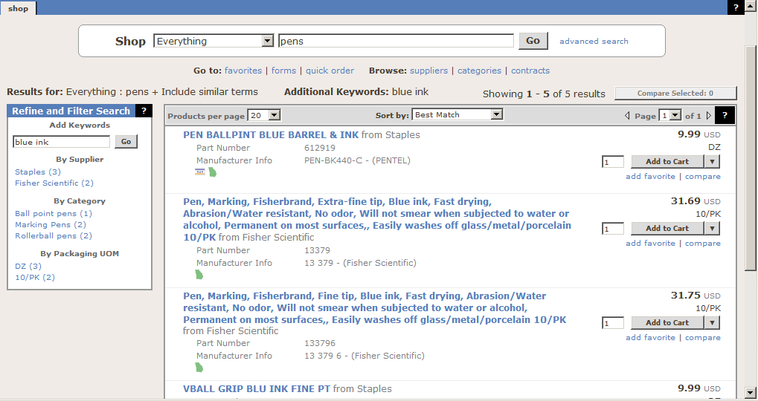

5 | This example shows a request for 50 dozen pens. To request the desired quantity, enter the amount into the Add to Cart field, and press the Add to Cart button.  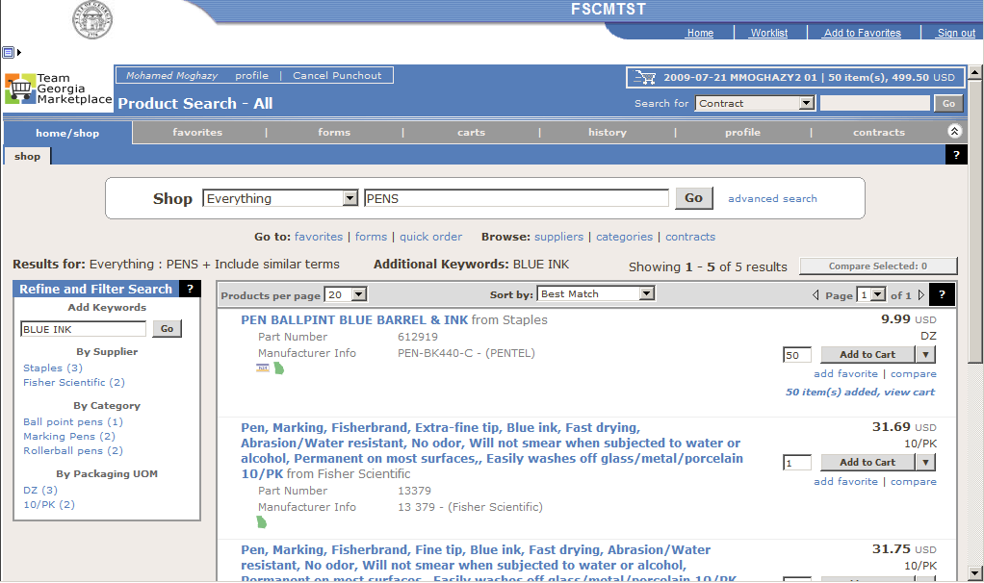
6 | Note that the Shopping Cart shows the number of items added to the cart. To display the Cart, click the Shopping Cart button at the top of the screen. Cart results are shown at the bottom of the screen. You have several options:  - Click the Save button to save the cart.  - Go to File>Print to print the cart.  - Go File>Print>Print to file to save a copy that can be emailed or scanned.  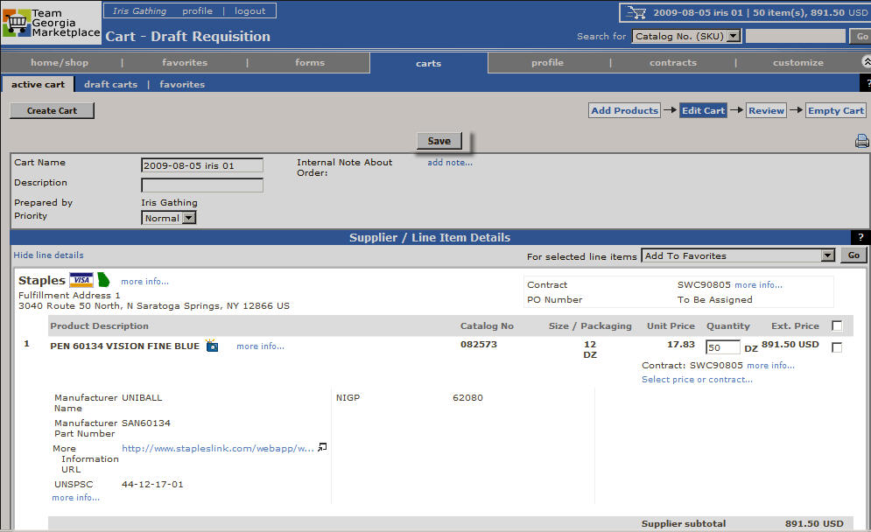
7 | End of Procedure

