Introduction
Pivot tables allow you to get different views of data by summarizing in two dimensions – rows that go down and columns that go across.
Any or all of the columns in the original spreadsheet can be reflected as rows, columns, or values in the pivot table to present the information you want in summary form. You are probably already familiar with what one looks like. The table below shows summary sales data from multiple regions for multiple quarters.

 | First Quarter | Second Quarter | Third Quarter | Fourth Quarter
Eastern Region | $10,000 | $15,000 | $12,000 | $13,000
Midwestern Region | $20,000 | $30,000 | $15,000 | $25,000
Southern Region | $30,000 | $40,000 | $20,000 | $10,000
Western Region | $25,000 | $15,000 | $30,000 | $25,000
Totals | $85,000.00 | $100,000.00 | $77,000.00 | $73,000.00
Behind all of these summary numbers, lie the thousands of individual transactions that make up those amounts. Instead of manually adding up all of those individual transaction amounts, Excel can do it for you.
These exercises are going to use purchasing card transaction data.

Some Preliminaries
Make sure your data spreadsheet has no gaps or spaces in it. In order for Excel to properly identify the data source, all columns must be contiguous. For example, you cannot create a pivot table from data in columns A-D and columns L-N. The same holds true for rows – you cannot create a pivot table from data in rows 1-10 and 20-30.
All columns of the spreadsheet with the data must have column headings. Excel will not recognize a column as being in the range if there is not one.
A good rule of thumb is that if you don’t want to do a calculation on a column, the data should be formatted as text, even if it is a number. For some Excel formulas to work correctly, these fields must formatted as text.

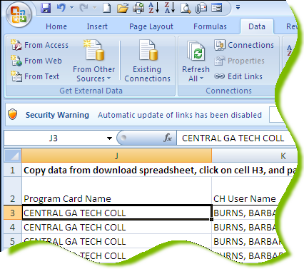
Step #1 – Initiate Pivot Table
The examples that follow use purchasing card transaction data. The data tab of the workbook has the individual transactions. You can click anywhere in the data range and Excel will identify the data to be used.

Click on
Insert Tab Pivot Table

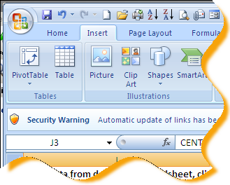

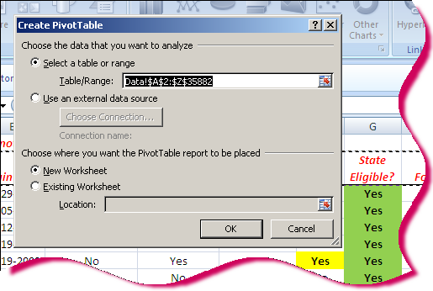
Step #2 – Define Data Range & Location of Pivot Table
Excel will identify the range of data on the spreadsheet. Most of the time, you will want to include all of the data in the pivot table. However, you can select the range manually and include just the contiguous columns and rows you want. For example, if you have data in A1:M2000 but you only want to use data in A1:D200, you can manually select that range. However, in our work, it is highly unlikely that we would want to pivot just part of the data (or data from multiple spreadsheets).
Click the radio button for either “New Worksheet” or “Existing Worksheet”. The default setting is “New Worksheet” and you will use this option most of the time. The other option is helpful if you want to have multiple pivot tables in a single workbook either on multiple data tabs or on the same data.
Click OK.

Excel Extra
To place the pivot table on an existing worksheet, click on the radio button and the red arrow at the end of the “Location” box. Navigate to the spreadsheet and the cell location (not just to the particular spreadsheet) where you want to put the table. Hit “Enter” and Excel will take you back to this dialog box. Click OK.

Step #3 – Design the Layout of the Pivot Table
This is the step where you determine what your pivot table will look like and how the data will be summarized. The different areas of a pivot table are:
- Values (fka Data) – this is the information that you are trying to summarize, or measure, or count.
- Report Filters (fka Page) – a “Report Filter” is useful if you have a lot of data and you will want to look at only one main group at a time. For example, if you have 100,000 purchasing card transactions at 100 Agencies, it might be easier to review one Agency at a time rather than all Agencies at once.
- Row – the “row” determines what columns from the data will be in the left-hand columns of the table. You can have as many rows as you have columns in the spreadsheet of data.
- Column – the “column” determines the names of the columns going across the pivot table.

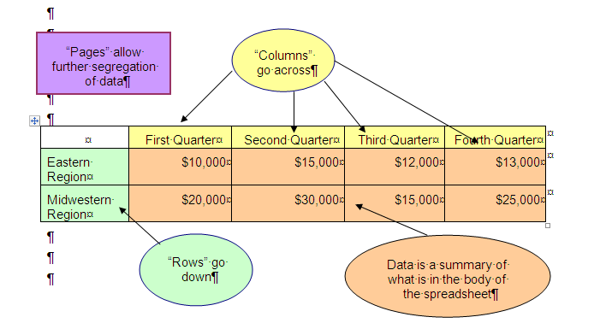The diagram to the right shows the relationship between rows and columns on the pivot table. What was called “Pages” in Excel 2003 (see purple box) is now called “Report Filters” in Excel 2007.

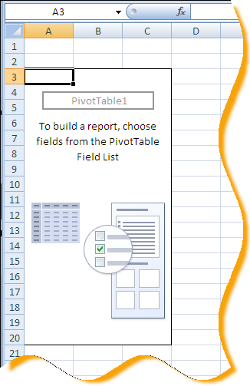

The pivot table layout screen is slightly different from that in Excel 2003. It has built-in formatting for Rows. To see the layout screen in the Excel 2003 version, click on “Options” in the top left-hand corner. Click on the “Display” tab and the “Classic Pivot Table layout” check box. Then click OK.
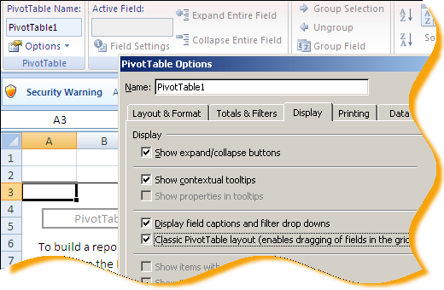

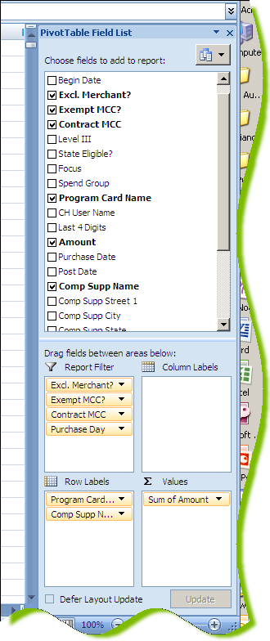
The column names (Pivot Table Field List) from the data spreadsheet are shown on the right-hand side of the screen.
To put any column in the Row Labels section, click on the box next to the column name. The rows will appear in the Row Labels box in the order shown in the list. If you want to re-arrange them, you can “drag and drop” the fields in that section into the desired order. You can also drag and drop field names to any of the areas shown instead of clicking on the box.
Any of the spreadsheet columns can also be put in the “Values” area. The most common use is to present the total of an amount field, such as transaction or purchase order amount. If Excel detects a numeric column, it should automatically choose the Sum of that amount for the Value. For any non-numeric columns, Excel defaults to Count of the rows.
The “Report Filter” area would be a good place to put the “Program Name” field in order to be able to filter on one Agency or University at a time. For Compliance audits, the vendor name from the 19D query would be a good candidate for a “Report Filter”.
Here, we have put the State Entity name and the vendor name, in that order, as the rows going down and the sum of the transaction amounts as the data. The total in column C will be the amount of spend for the State Entity (column A) at the merchant (column B).
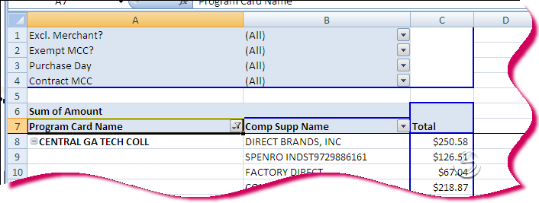
The Report Filters will be above the pivot table to allow filtering.

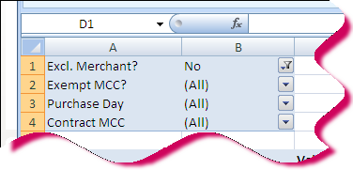
When using the Report Filters, only data rows that match ALL of the values selected in the filters will display. For example, in the illustration here, records where the merchant has been identified as “Excluded” from review, regardless of whether or not the MCC is exempt (because of the probable NIGP code), regardless of the day of the week on which the purchase was chosen, and regardless of whether or not there is a contract merchant with the same MCC.

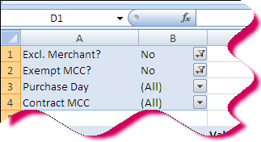
As another example, applying the filters as shown here will pull all transactions at merchants where (1) the merchant has not been excluded and (2) the MCC is not exempt because of the probable NIGP code.

Step #4 – Formatting the Numbers
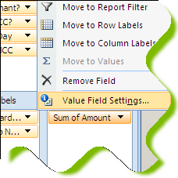
Click on the “Sum of Amount” button in the Values area. When the pop-up menu appears, click on “Value Field Settings…”.
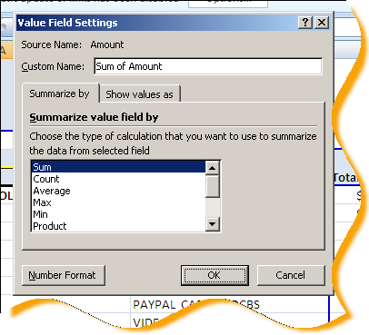

Most of the time, you will want to choose the Sum of the amount field. Click on the “Number Format” button to select the format (e.g. General or Currency).
Click the OK button in the Value Field Settings dialog box when finished.

Excel Extra:
There might be times when you want to count the occurrence of the amounts, such as when you want to know how many transactions for $50.92 we have. This is probably not very useful. However, you might want to count the number of transaction numbers or purchase order numbers.

Step #5 – Modifying the Pivot Table
The pivot table will display on the screen. From here, you can remove columns or rows. You can also drag and drop other spreadsheet columns to rows or columns of the pivot table.
Drag the “Credit Limit” field to the Values area. Notice that the default is “Count” of the Credit Limit. Excel assumes that you want to count the number of rows with something in this field. In this example, it will count the number of rows for each merchant name. In this spreadsheet, the Number column represents the transaction number. You can use a “count” of any field to determine the number of data rows associated with the field names shown in the Row Labels area.
The pivot table now displays the Count of Credit Limit. The table will automatically display the data fields the way it thinks you want to. Spreadsheet columns that are formatted as numbers or currency will automatically be inserted in the data area as a “sum” of the amount. Text fields will automatically be inserted as “count” of the values. If any of this is not correct, you can change it.
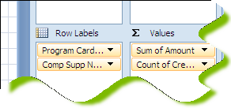

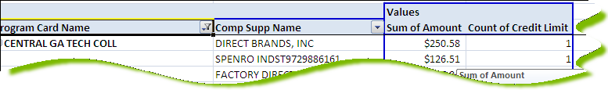

Now, delete the Credit Limit field from the Values area and drag and drop the amount column into the data area.
You will now see Count of Amount. This kind of summary doesn’t make much sense, but you might want to see the largest transaction amount or the smallest transaction amount.
To change the summarize option for the additional amount field, click on the Max option in the Summarize by: area. Click on the Number… button to format the number as Currency and click OK.
Notice that you can also do “average” amount and smallest (“min”) amount.
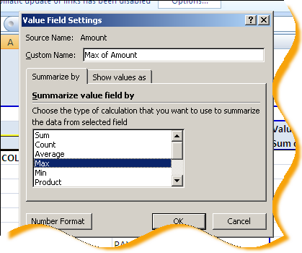
You will now see the Total Amount of spend at the merchant as well as the largest transaction at the same merchant.
If you don’t like the default names, these can be changed in the PivotTable Field dialog box.
Change the Max of Amount to Largest Transaction here.
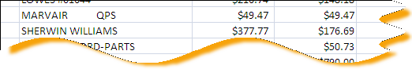

In this example, the total spend and the largest transaction were the same for Marvair QPS, so there must have been just one transaction. However, the total spend at Sherwin Williams was $377.77 with the largest transaction being $176.69.
To view the details behind any number, double-click on the number. Excel will display the individual lines in a new worksheet.

Pivot Table Extras

Filtering a Pivot Table
Drop-down lists for the Report Filters, Column Labels, and Row Labels areas can be used to filter what is shown on the screen just like using filters on a standard spreadsheet. Click the drop-down arrow and select the values to show.
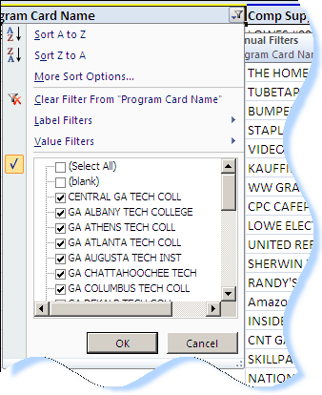
Note that you can also begin a sort on the column from this option.
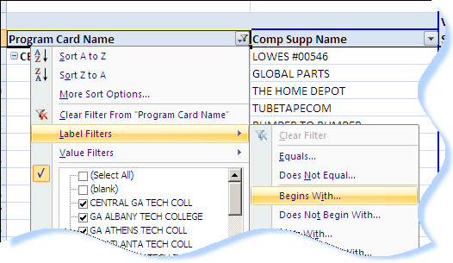
To apply custom filters, click on the Label Filters bar and then use one of the custom options. This will save time if you have a long list of values and you know that a lot of them begin with the same letter or word. For example, you can select “Begins With…” and enter the letter “B” to see all values in the Row Label that begin with the letter “B”.

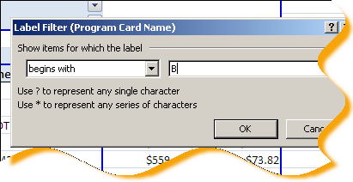

Applying Conditional Formatting
You can apply conditional formatting to a cell or range of cells just like you would in a standard spreadsheet. Click on the cell or the range of cells you wish to apply conditional formatting to.

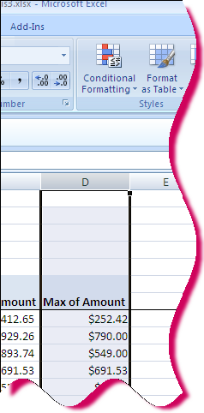
On the Home tab, click on Conditional Formatting…
The Conditional Formatting drop-down menu will appear. In Excel 2003, you can have up to three conditional formats. However, in Excel 2007, you can apply more than this.
Select Manage Rules… .
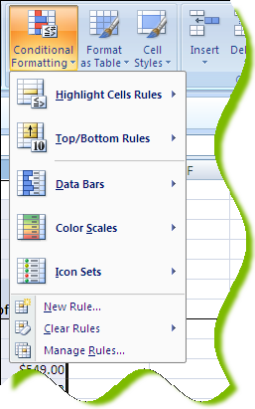

Select “New Rule”
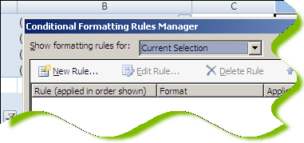

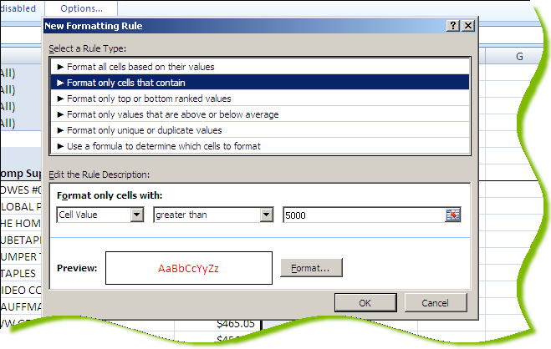
Click on “Format only cells that contain” and enter the criteria and desired format in the dialog box. Click OK when finished. In this example, cells containing a value greater than $5,000 will be in red font.

To add additional conditional formatting, repeat the above steps for all desired formatting.

Removing Subtotals
Whenever you put in two or more spreadsheet columns in the “row” area, the pivot table will automatically insert totals for each row.
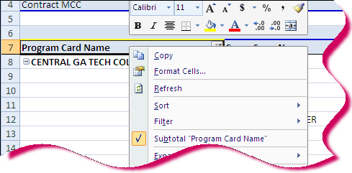
Sometimes this is helpful, sometimes it is not, especially when you have two or more spreadsheet columns represented as rows. To eliminate the subtotals, right-click on the Row Label that has the subtotals. In this illustration, that would be the Program Card Name row section.
To remove the subtotals, click on the “Subtotal…” bar to toggle the subtotals off. To reinstate the subtotals, simply right-click on the Row Label name and click on the “Subtotal…” bar.

Sorting a Pivot Table
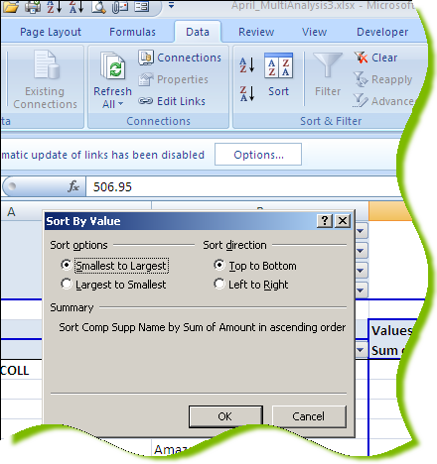
Sorting a pivot table is not quite the same as sorting a regular spreadsheet. The table automatically sorts by the row values. However, we might want to view data in descending order by amount to see which vendor has the most spend.
To sort the pivot table by the amount, click anywhere in the Total column. Click the Data tab and Sort… on the menu bar. The pivot table Sort dialog box will appear.
Click on the “Smallest to Largest” or “Largest to Smallest” radio button.
Click OK to return to the pivot table. The Row Labels will be sorted in the selected order by amount. The labels automatically sort correctly.

You might also want to sort the pivot table by merchant name. Click anywhere in the merchant name column and click Data Sort. A different dialog box will display. Click on the radio button for either “Ascending” or “Descending” and select the field to sort in the drop-down list. The choices will be the column that you have clicked in on the pivot table and the Value fields (e.g. Sum of Amount).
