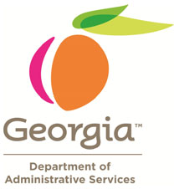
doas.ga.gov
404.656.6245

PROPERTY PROGRAM
LOSS CONTROL TIP

The head of your organization has agreed to a partnership with the Department of Administrative Services in a plan aimed at Of the 2,760 claims reported into the Property Program for fiscal years 2004 thru 2014, 865 involved theft of property and the majority of the property thefts involved computers.

We want to bring to your attention, theft tracking software that can be loaded onto your computer to locate it when stolen, similar to a LoJack device installed in a vehicle. For certain laptops that have a built-in camera, it can even trigger the camera to take pictures after it has been stolen to further assist law enforcement in getting back your laptop computer.

During these tight budgetary times, in addition to the commercial theft tracking software available for purchase, we want to call to your attention FREE laptop theft tracking software provided by the University of Washington http://adeona.cs.washington.edu/. Please consult with your Agency’s Information Technology experts to see if this FREE laptop theft protection software is right for you!

Load theft tracking software on your computer!

