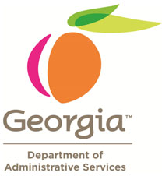
doas.ga.gov
404.656.6245
Jerome.Wright@doas.ga.gov

LIABILITY INSURANCE
EXCESS LIABILITY FREQUENTLY ASKED QUESTIONS

Through Governor Deal’s initiative effective July 1, 2016, the State of Georgia began providing excess liability insurance at no cost to Georgia’s Certificated School Teachers and Staff. The program is administered and paid for by the Department of Administrative Services.
The following providers a sampling of FAQ that can be used when communicating the benefit to Staff.
Frequently Asked Questions
1. Are Pre-K teachers eligible for the Coverage?
• Pre-K teachers who are employed within a School System will have coverage as employees of the Local Educational Agency and/or school system who owns and runs Pre-K.
2. Who pays for the program?
• The program is provided at no cost to the Teachers and Certificated Staff. There is no charge for the program to the School System.
3. How does an individual enroll for the program?
• There are no enrollment forms needed. DOAS Risk Management provided a number of covered lives to the insurance carrier and will need to report updated figures at the end of the policy period. Each individual Teacher or Certificated Staff member will not have to complete any type of enrollment form.
4. Does this program impact any other coverage an individual may have in place?
• The program provides Excess Professional Liability Insurance coverage limits over any Primary Coverage that the school system may provide the Teachers or Staff, or any other coverage the Teachers or Staff may have through a professional organization.
5. What is the claims submission process?
• Claims will need to be submitted to DOAS. A Claims Processing document is available on the DOAS website.

