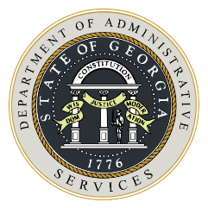
Bidders/Offerors Conference Agenda
State of Georgia Department of Administrative Services

 | Solicitation Information
 |  | State Entity Name |  | Solicitation Number
 |  | Solicitation Name |  | Meeting Date (mm-dd-yy)

- Welcoming Remarks
  - Introduction (Issuing Officer, Presenters, Attendees)

  - This is a Bidders/Offerors’ conference for…

  - The purpose of this meeting is to share information about the solicitation process and to allow interested firms the opportunity to ask questions.

- General Information and Reminders
- Reminder about prohibition on communications with other state staff.
- Reminder to post questions to Sourcing Tools’ Q&A Board and to view published answers.
- Reminder to be alert to system notifications. If solicitation is amended, any supplier who has already submitted bid response will be required to re-submit prior to the closing date and time.
- Reminder of solicitation closing date/time; submit your bid early!

- Q&A Session
- Invite attending suppliers to share questions.
- Issuing officer to help facilitate by identifying questions which may be answered now or whether questions will be reviewed further with response published to Q&A Board.

- Closing Remarks
- Access to DOAS’ website for supplier training references.
- Contact DOAS Help Desk as needed for technical support.

