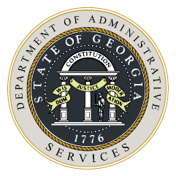
Sole Brand Justification
State of Georgia Department of Administrative Services

Instructions for State Buyer
Sole Brand Solicitation: As described in the Georgia Procurement Manual Section 2.3.1, a sole brand solicitation is a competitive solicitation which includes specifications restricting offered goods or technology to a specific manufacturer or owner’s brand. Before deciding that only one specific brand of goods will meet the state entity’s critical business requirements, research must be conducted by the procurement professional to determine if other brands exist which can also satisfy the procurement requirements in a timely manner. Sound procurement practice requires that a sole brand solicitation be used only when it is the last justifiable option, and not as an attempt to contract for a favored brand of goods. This form must be completed and attached to the solicitation. All other requirements for posting and processing a competitive solicitation apply.

 | Organizational Information
 |  | State Entity Name |  | Date of Request

Description of Materials/Scope of Work
Provide a detailed description of the goods, services, and technology required. Indicate where and how the item or service is to be used, operational environment, historical use, etc.

Sole Brand Justification
Explain why only a particular style, model, type or manufacturer is acceptable. For example, to match existing uniforms. Please describe research and any efforts made to identify and assess other possible solutions.

 | State Entity Approvals
 |  | Name of Originator of Request |  | Signature
 |  | APO/CUPO |  | Signature
 |  | Department Head |  | Signature

